**Ideation Phase**

**Define the Problem Statements**

| Date | 31 January 2025 |
| --- | --- |
| Team ID | LTVIP2025TMID59352 |
| Project Name | ShopSmart:Your digital grocery store experience |
| Maximum Marks | 2 Marks |

**Customer Problem Statement Template:**

Create a problem statement to understand your customer's point of view. The Customer Problem Statement template helps you focus on what matters to create experiences people will love.

A well-articulated customer problem statement allows you and your team to find the ideal solution for the challenges your customers face. Throughout the process, you’ll also be able to empathize with your customers, which helps you better understand how they perceive your product or service.

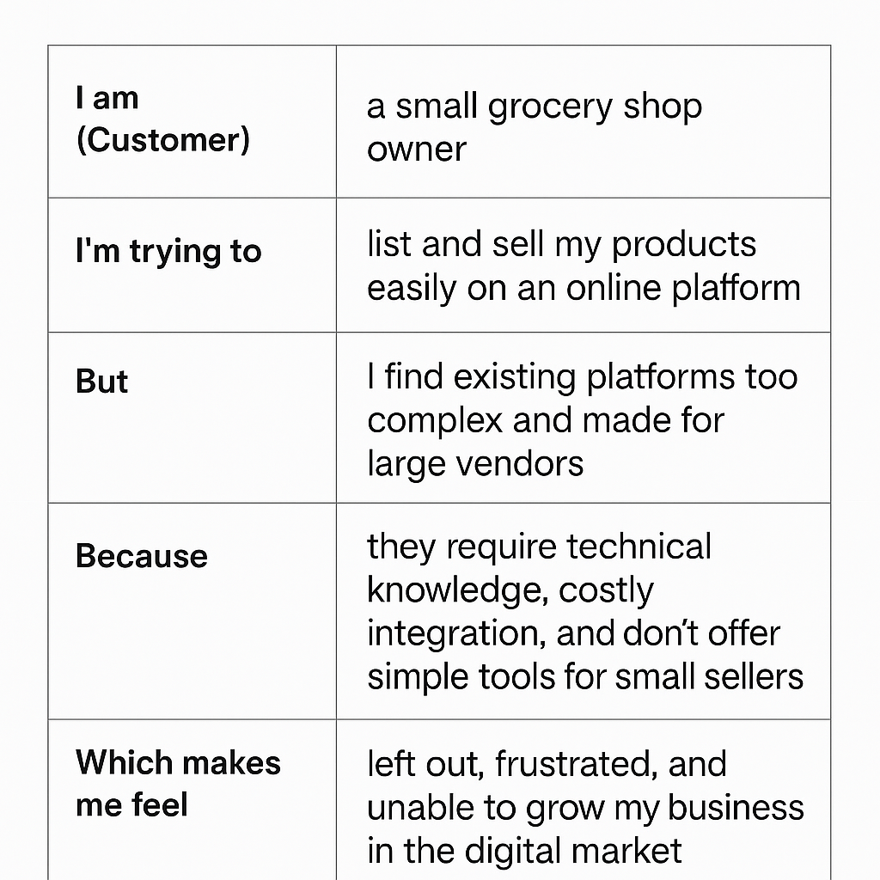

Reference: <https://miro.com/templates/customer-problem-statement/>

**Example:**

| **Problem Statement (PS)** | **I am (Customer)** | **I’m trying to** | **But** | **Because** | **Which makes me feel** |
| --- | --- | --- | --- | --- | --- |
| PS-1 | a busy professional who has limited time for grocery shopping | quickly purchase quality groceries online with minimal effort | the apps I use are cluttered, slow, and not personalized | they don’t remember my preferences or suggest relevant products | frustrated, rushed, and less likely to use online grocery services |
| PS-2 | a small grocery shop owner | list and sell my products easily on an online platform | I find existing platforms too complex and made for large vendors | they require technical knowledge and costly integration | left out, disempowered, and unable to grow my business online |